Course Number | CPS 8319
Course Title | Reinforcement Learning
Semester/Year
Section Number
Group Number | 7
`  Student Name | Student ID (xxxx1234)
John Cook-Martin | 2923 | J.CM
Pari Qarehdaghi | 4602 | P.Q

Assignment No.1

Assignment Title | Question 3, Tic, Tac, Toe
Submission Date | 2026-02-04
Due Date | 2026-02-04
Contents
Report 3 — Tic-Tac-Toe Learning Agent 4
Introduction 4
Action Selection Strategy 4
Opponent Models 5
Results Against Fixed Opponents 6
Random Opponent 6
Same Row Opponent 7
Same Column Opponent 8
Diagonal Opposite Opponent 9
Mirror Opponent 10
Self-Play Results 10
Discussion and Observations 12
Effect of Exploration on Learning Robustness 12
Impact of Opponent Structure on Learning Speed 12
Difficulty of Self-Play Scenarios 12
Efficiency of Bitboard State Representation 13
Overall Interpretation 13
Conclusion 13
References (MLA) 15

Figure 1: Win Rate vs Random Opponent Experiment 1 6
Figure 2: Win Rate vs Random Opponent Experiment 2 6
Figure 3: Win Rate vs Random Row Opponent Experiment 1 7
Figure 4: Win Rate vs Random Row Opponent Experiment 2 7
Figure 5: Win Rate vs Random Column Opponent Experiment 1 8
Figure 6: Win Rate vs Random Column Opponent Experiment 2 8
Figure 7: Win Rate vs Random Diagonal Opponent Experiment 1 9
Figure 8: Win Rate vs Random Diagonal Opponent Experiment 2 9
Figure 9: Win Rate vs Random Mirror Opponent Expirement 1 10
Figure 10: Win Rate vs Random Mirror Opponent Experiment 2………………………… 11
Figure 11: Win Rate vs Self Experiment 1 12
Figure 12: Win Rate vs Self Experiment 2 12

Report 3 — Tic-Tac-Toe Learning Agent

Introduction
In this assignment, a reinforcement learning agent is implemented to learn how to play the game of Tic-Tac-Toe as the first player (X). The learning approach follows the state-value based temporal-difference (TD) learning framework described in Reinforcement Learning: An Introduction by Sutton and Barto. The agent interacts with the environment by playing repeated games against several naive opponent strategies and improves its policy by updating a value function over the board states.
The objective is to evaluate how the learning agent adapts its policy when facing opponents that follow simple, biased strategies rather than optimal play. The agent’s performance is measured using the win rate as a function of the number of training games.
State Representation and Initialization
Each Tic-Tac-Toe board configuration is represented as a state composed of the agent’s moves (X) and the opponent’s moves (O). The board is encoded using bitwise representations, and the two bitboards are combined into a single state identifier.
A state-value function $V(s)$is maintained for all encountered states. The values are initialized as follows:
- Win: value = 1
- Draw / non-terminal: value = 0.5
- Loss: value = 0
Assigning non-terminal states an initial value of 0.5 reflects uncertainty about their outcomes and follows the approach described in the Tic-Tac-Toe example by Sutton and Barto.

Action Selection Strategy
The agent selects actions using an ε-greedy policy. At each decision step:
- With probability $ϵ$, the agent selects a random legal move (exploration).
- With probability $1-ϵ$, the agent selects the move that leads to the state with the highest estimated value (greedy exploitation).
This strategy allows the agent to explore unfamiliar states while gradually exploiting its learned value estimates.
Learning Rule
Learning is performed using temporal-difference learning (TD(0)). After each move, the value of the previous state is updated using the following rule:
$$V(s_{t})←V(s_{t})+α\left[V(s_{t+1})-V(s_{t})\right]$$
where:
- $s_{t }$is the previous state,
- $s_{t+1}$is the resulting state after the move,
- $α$is the learning rate.
In the implemented algorithm, value updates are applied after every move, regardless of whether the move was selected greedily or randomly. Therefore, the agent learns from both greedy and exploratory actions, consistent with ε-greedy TD learning.

Opponent Models
The agent is evaluated against several opponent strategies:
- RANDOM: selects any legal move uniformly
- RANDOM_ROW: prefers moves in the same row as the agent’s previous move
- RANDOM_COL: prefers moves in the same column
- RANDOM_DIAG: prefers diagonal moves when applicable
- MIRROR: mirrors the agent’s previous move
- SELF: plays against another learning agent
If an opponent’s preferred move set is unavailable, it falls back to random play
Experimental Setup
- Maximum number of games: 10,000
- Learning rate: α = 0.1
- Exploration rates: ε = 0 and ε = 0.1
- Convergence criterion:
  - Training stops early if the average absolute change in state values drops below 0.001 after at least 100 games
- Performance metric:
  - Running average win rate
Each experiment tracks how quickly and how reliably the agent converges to a strong policy.

Results Against Fixed Opponents

Random Opponent
The agent rapidly improves against a fully random opponent. Even with no exploration (ε = 0), the win rate steadily increases and stabilizes above 90%.
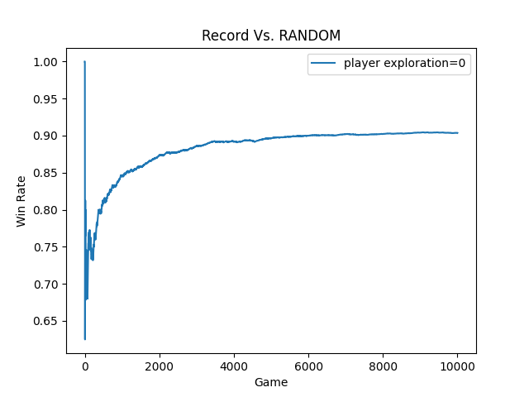
Figure 1: Win Rate vs Random Opponent Experiment 1
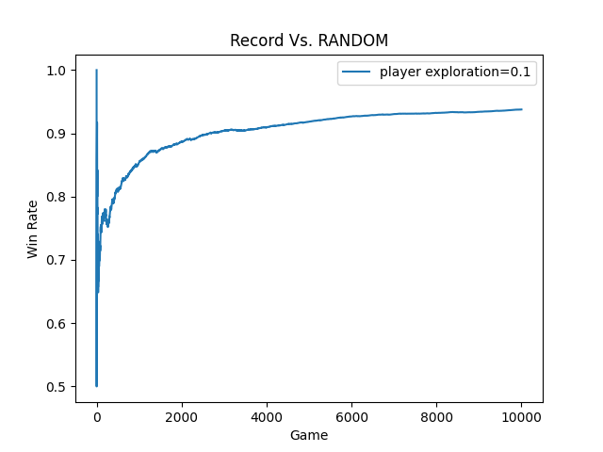
Figure 2: Win Rate vs Random Opponent Experiment 2
Exploration slightly improves stability during early learning but is not strictly necessary due to the opponent’s lack of structure.

Same Row Opponent
Against the RANDOM_ROW opponent, the agent learns to exploit predictable row-based behavior. Convergence is faster than in the fully random case, with win rates approaching 95–98%.
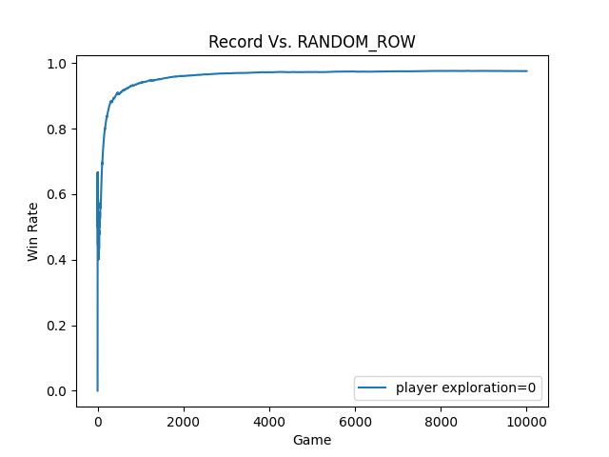
Figure 3: Win Rate vs Random Row Opponent Experiment 1
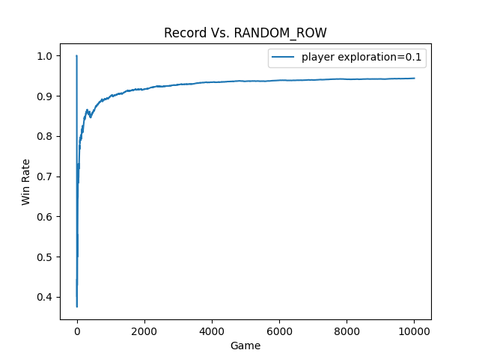
Figure 4: Win Rate vs Random Row Opponent Experiment 2
This demonstrates that the learning agent can effectively identify and exploit structural weaknesses in opponent strategies.

Same Column Opponent
Similar behavior is observed against the RANDOM_COL opponent. The agent adapts to column-based patterns and achieves a high final win rate.
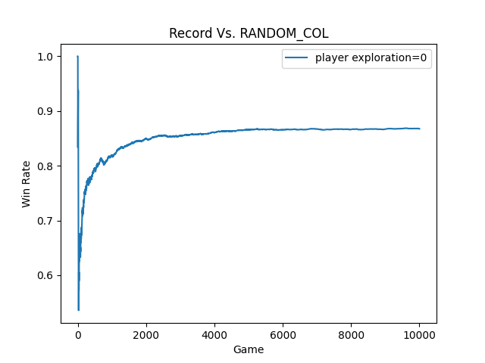
Figure 5: Win Rate vs Random Column Opponent Experiment 1
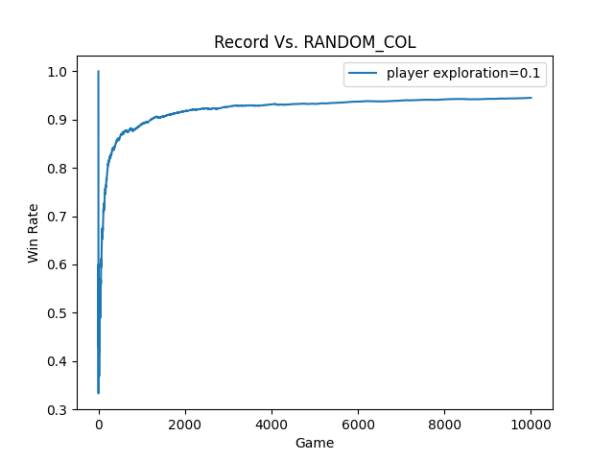
Figure 6: Win Rate vs Random Column Opponent Experiment 2
Exploration accelerates learning by preventing premature convergence to suboptimal move sequences.

Diagonal Opposite Opponent
Diagonal preference introduces a slightly more complex opponent pattern. Nevertheless, the agent successfully learns strong counter-strategies and converges to a win rate above 90%.
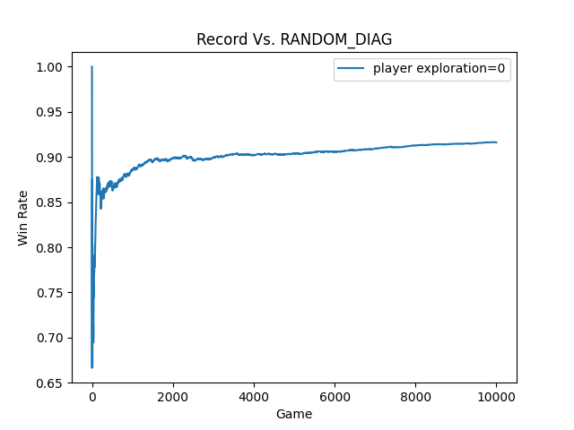
Figure 7: Win Rate vs Random Diagonal Opponent Experiment 1
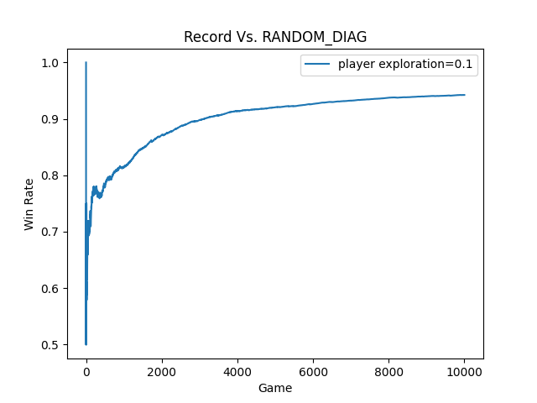
Figure 8: Win Rate vs Random Diagonal Opponent Experiment 2
This case highlights the benefit of exploration during early training.

Mirror Opponent
The MIRROR opponent presents the easiest scenario for the model because it’s moves are effectively completely controlled by the model. Learning is so fast that even when using a purely greedy algorithm, the state values converge before 600 games played. In the greedy epsilon approach the results are only worse because the forced exploration sometimes leads to losses by the agent.
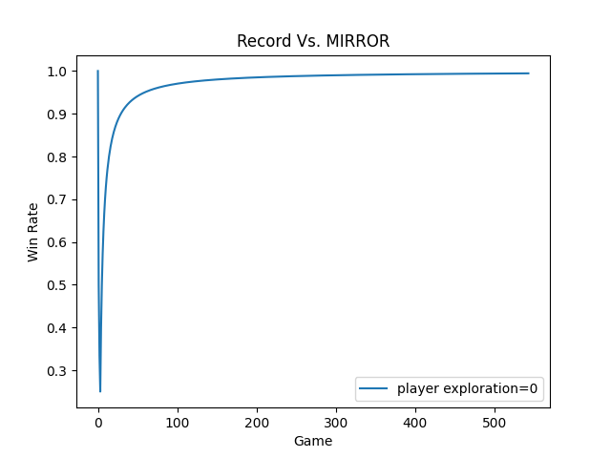
Figure 9: Win Rate vs Random Mirror Opponent Experiment 1
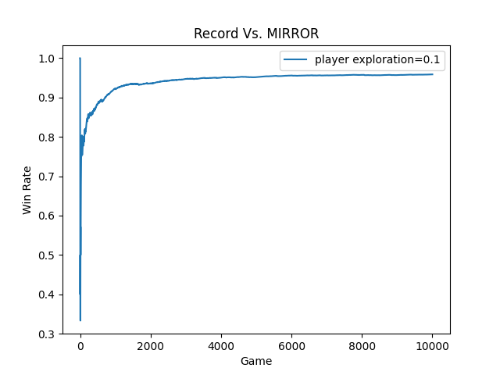
Figure 10: Win Rate vs Random Mirror Opponent Experiment 2

Exploration (ε = 0.1) plays a critical role in escaping symmetric traps early in training.

Self-Play Results
In self-play, both agents adapt simultaneously, resulting in slower convergence and a lower final win rate (approximately 80–85%).
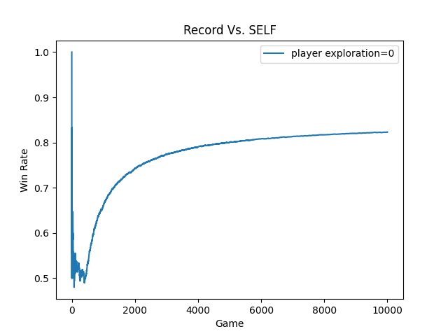
Figure 11: Win Rate vs Self Experiment 1
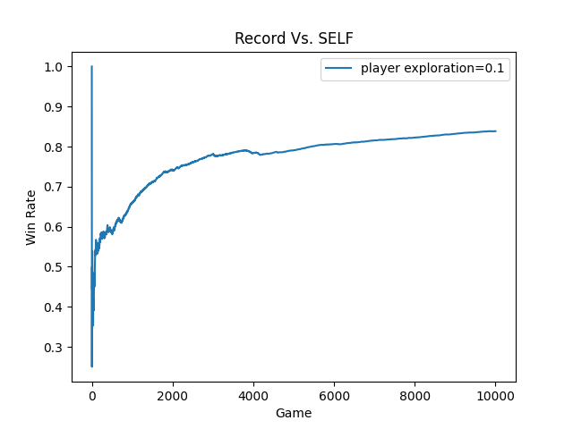
Figure 12: Win Rate vs Self Experiment 2
This behavior is expected, as the environment becomes non-stationary. The result demonstrates that learning against adaptive opponents is inherently more difficult than learning against fixed strategies.

Discussion and Observations
Several important observations emerge from the Tic-Tac-Toe learning experiments.

Effect of Exploration on Learning Robustness
Introducing exploration through a nonzero exploration rate (ε-greedy strategy) significantly improves the robustness of the learning agent. When exploration is enabled, the agent occasionally selects random legal moves rather than always exploiting the currently highest-valued state. This behavior prevents premature convergence to suboptimal policies, which can occur when early experiences bias the value estimates incorrectly. The experimental results show that agents with exploration consistently achieve smoother learning curves and higher final win rates, particularly when facing structured or adaptive opponents. In contrast, agents with zero exploration are more susceptible to early mistakes becoming permanently reinforced.

Impact of Opponent Structure on Learning Speed
Opponents that follow structured and predictable strategies—such as always selecting moves from a specific row, column, or diagonal—are significantly easier for the learning agent to exploit. Because these opponents exhibit consistent behavioral patterns, the agent rapidly identifies high-value counter-moves and converges to strong policies within fewer games. This is reflected in faster win-rate growth and higher asymptotic performance in the corresponding plots. The results demonstrate that learning automata and temporal-difference learning are particularly effective in environments where the opponent behavior is stationary and structured.

Difficulty of Self-Play Scenarios
Self-play presents the most challenging learning scenario. In this setting, both players continuously adapt their strategies based on ongoing experience, resulting in a non-stationary environment. As both agents improve simultaneously, previously learned advantages may become obsolete, slowing convergence and increasing variance in the learning process. The experimental results show slower improvement in win rate and lower asymptotic performance compared to games against fixed-strategy opponents. This highlights the inherent difficulty of learning in competitive multi-agent environments where opponent behavior evolves over time.

Efficiency of Bitboard State Representation
The use of a bitboard-based state representation significantly enhances computational efficiency and learning performance. By encoding the game board using compact binary representations for player and opponent moves, the state space can be efficiently stored, compared, and reused. This representation enables rapid state lookup, efficient win detection, and effective reuse of learned state values across games. As a result, the agent can explore and learn from many game states within a reasonable computational budget, contributing to faster convergence and stable learning behavior.

Overall Interpretation
Collectively, these results demonstrate that the combination of ε-greedy exploration, efficient state representation, and incremental value updates enables effective learning in discrete adversarial environments. While structured opponents are exploited quickly, adaptive opponents such as in self-play require sustained exploration and longer training to achieve stable performance. The experiments validate both the correctness and practical effectiveness of the implemented learning algorithm.

Conclusion
In this question, a reinforcement learning agent was implemented to learn optimal Tic-Tac-Toe play through repeated interaction with various opponent strategies. Using a state-value update rule and an ε-greedy action selection policy, the agent successfully learned effective policies over time.
The results show fast convergence and high win rates against random and structured opponents (row, column, and diagonal), demonstrating that predictable strategies are easier to exploit. Incorporating exploration improves learning robustness by preventing premature convergence to suboptimal behaviors. Self-play proved to be the most challenging setting, as mutual adaptation slowed convergence and reduced final win rates compared to fixed opponents.
The compact bitboard state representation enabled efficient learning by allowing fast state evaluation and reuse of learned values across games. Overall, the experiments confirm that simple reinforcement learning methods, combined with effective exploration and state representation, can achieve strong performance in adversarial games such as Tic-Tac-Toe.

References (MLA)
Sutton, R. S., & Barto, A. G. (2018). Reinforcement Learning: An Introduction (2nd ed.). MIT Press.
Chapter 1, Section 1.5: An Extended Example: Tic-Tac-Toe.

